**HTML5 ASSIGNMENT**

**Q.1. What are new tags added in HTML5?**

**A-** New tags which are added to HTML5 are :-

1. **<article>** -It represents an independent piece of content of a document such as a blog entry or newspaper article.
2. **<audio>** - It is used to defines an audio file.
3. **<canvas>** - It is used for rendering dynamic bitmap grafics on the fly, such as graphs or games.
4. **<command>** - It represents a command the user can invoke.
5. **<embed>** - It defines external interactive content or plugin.
6. **<video>** - It defines a video file.
7. **<time>** - It represents a date and time.
8. **<wbr>** - It represents a line break opportunity.
9. **<nav>** - It represents a section of the document intended for navigation.
10. **<details>** - It represents additional information or controls which the user can obtain on demand.

-------------------------------------------------------------------------------------------------------------------------

**Q.2. How to embed audio and video in a webpage?**

**A-**

1. **audio tag**- To embed audio in HTML, we use <audio> tag. The current HTML5 draft specification does not specify which audio formats browsers should support in the audio tag, but most commonly used audio formats are ogg, mp3 and wav.

Syntax-

<audio src=”file_name” controls>

</audio>

* **Attributes of <audio> tag:-**

1. autoplay - This attribute if specified, the audio will automatically begin to play back as soon as it can do so without stopping to finish loading the data.

2. controls – This attribute will allow the user to control audio playback including volume, seeking and pause/resume playback.

3. loop – This attribute will allow audio automatically seek back to the start after reaching at the end.

4. src – The URL of the audio to embed. This is optional, you may instead use the <source. Element within the video block to specify the video to embed.

5. preload – This attribute specifies that the audio will be loaded at page load, and ready to run.

2. **video tag-** In HTML5, the video tag is used to embed video file in webpage. The current HTML5 draft specification does not specify which video formats browsers should support in the video tag. But most commonly used video formats are-

* Ogg – ogg files with Thedora video codec and Vorbis audio codec.
* Mpeg4 – MPEG4 files with H.264 video codec and AAC audio codec.

Syntax-

<video src=”file name” width=”” height=”” controls></video>

* **Attributes of <video> tag :-**

1. autoplay – This attribute if specified, the video will automatically begin to to play back as soon as it can do so without stopping to finish loading the data.

2. controls – This will allow the user to control video playback, including volumes, seeking and pause/resume playback.

3. loop – This will allow video automatically seek back to the start after reaching at the end.

4. height – This specifies the height of the videos’s display area.

5. width – This specifies the width of the video’s display area.

e.g.

<!DOCTYPE html>

<html lang="en">

<head>

<meta charset="UTF-8">

<meta http-equiv="X-UA-Compatible" content="IE=edge">

<meta name="viewport" content="width=device-width, initial-scale=1.0">

<title>Document</title>

</head>

<body>

<audio src="C:\Users\Admin\Downloads\Shiv Tandav Stotram - Mahashivaraatri - Top 10 128 Kbps.mp3" controls></audio>

<video height="500" width="500" src="E:\Vijay and swapna\WP_20160126_049.mp4" controls loop></video>

</body>

</html>

**Output:-**

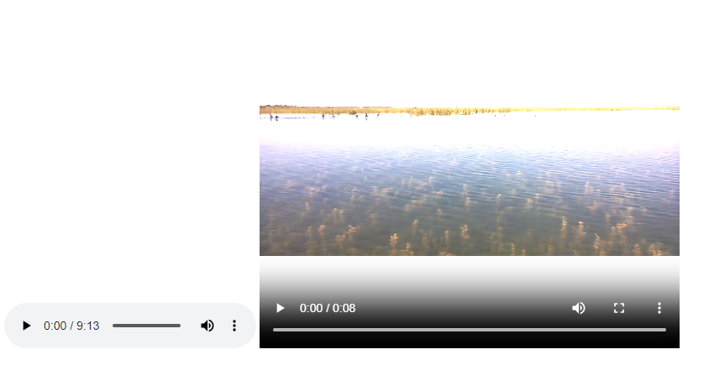

-------------------------------------------------------------------------------------------------------------------------------------

**Q.3. Semantic element in HTML5?**

**A- Semantic elements:-** Semantic elements have meaningful names which defines about type of content. HTML5 introduces many semantic elements which make the code easier to write and understand for the developer as well as instructs the browser on how to treat them.

1. Article - It contains independent content which doesnot require any other context. E.g. blog post, newspaper article etc.
2. Aside – It is used to place content in a sidebar I.e. aside the existing content.
3. Header – It is used for the header of a section introductory of a page. There can be multiple headers on a page.
4. Footer – Footer located at the bottom of any article or document, they can contain contact details, copyright information etc. There can be multiple footers on a page.
5. Main – It defines the main content of the document. The content inside main tag should be unique.
6. Section – A page can be split into sections like introduction, contact information, details etc and each of these sections can be in a different section tag.
7. Nav – It is used to define a set of navigation links in the form of navigation bar or nav menu.
8. Mark – It is used to highlight the text.

e.g.

<!DOCTYPE html>

<html lang="en">

<head>

<meta charset="UTF-8">

<meta http-equiv="X-UA-Compatible" content="IE=edge">

<meta name="viewport" content="width=device-width, initial-scale=1.0">

<title>Document</title>

<style>

header{

background-color: aqua;

display: flex;

}

h1{

color: brown;

text-align: center;

}

nav{

padding: 20px;

text-align: center;

}

main{

background-color: azure;

}

h2{

text-align: center;

}

footer{

background-color: black;

}

#one{

text-align: center;

color: white;

}

</style>

</head>

<body>

<header>

<h1>HEADER</h1>

<nav>

<a href="">HOME</a>

<a href="">ABOUT</a>

<a href="">BLOG</a>

<a href="">CONTACT</a>

</nav>

</header>

<main>

<h2>Main Section</h2>

<p>Lorem ipsum dolor, sit amet consectetur adipisicing elit. Qui, ab velit saepe quis ipsum, reprehenderit voluptatum hic aliquid doloribus recusandae adipisci harum voluptatem fugit! Voluptatibus quod autem nemo itaque distinctio!</p>

</main>

<footer>

<p id="one">Footer</p>

</footer>

</body>

</html>

**Output:-**

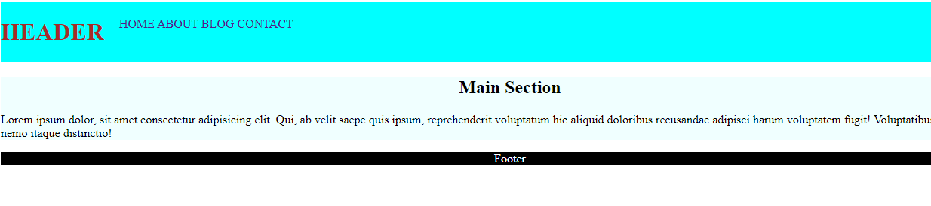-------------------------------------------------------------------------------------------------------------------------------------

**Q.4. Canvas and SVG tags.**

**A- Canvas –**

The HTML element is used to draw graphics on the fly, via scripting. The element is only a container for graphics. You must use a script to actually draw the graphics. Canvas has several methods for drawing paths, boxes, circle, text and adding images. Canvas gives better performance with smaller surface or larger number of objects. Canvas diagram can be saved to PNG or JPG format.

e.g.

<!DOCTYPE html>

<html lang="en">

<head>

<meta charset="UTF-8">

<meta http-equiv="X-UA-Compatible" content="IE=edge">

<meta name="viewport" content="width=device-width, initial-scale=1.0">

<title>Document</title>

</head>

<body>

<h1>Canvas square</h1>

<canvas id="canvas" width="100" height="100" style="border : 1px solid #000000"></canvas>

<script>

var c = document.getElementById('canvas');

var ctx = c.getContext( '2d');

ctx.fillStyle = '#7cce2b';

ctx.fillRect(0, 0, 100, 100);

</script>

</body>

</html>

**Output:-**

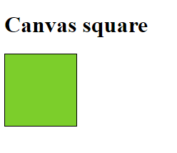

**SVG tag –**

The SVG stands for Scalable Vector Graphics. It is an XML based image format that is used to define two dimensional vector based graphics for the web. An SVG image is drawn out using a series of statement that follows the XML schema, that means SVG images can be created and edited with any text editor, such as notepad. SVG has better scalability. So it can be printed with high quality at any resolution. It can be modified through script and CSS.

e.g.   
<!DOCTYPE html>

<html lang="en">

<head>

<meta charset="UTF-8">

<meta http-equiv="X-UA-Compatible" content="IE=edge">

<meta name="viewport" content="width=device-width, initial-scale=1.0">

<title>Document</title>

<style>

#svg1{

position: relative;

left: 50%;

-webkit-transform: translateX(-20%);

-ms-transform: translateX(-20%);

transform: translateX(-20%);

}

</style>

</head>

<body>

<h2 align="center">

SVG circle

</h2>

<svg id="svg1" height="200">

<circle id="greencircle" cx="60" cy="60" r="50" fill="green"></circle>

</svg>

</body>

</html>

**Output:-**

